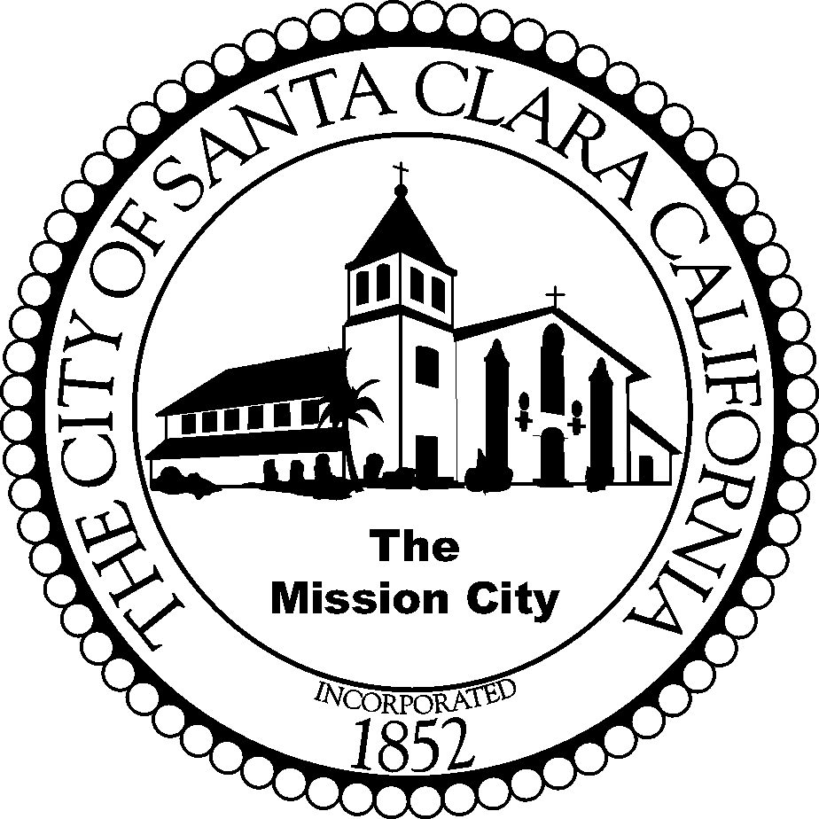

CITY OF SANTA CLARA
PARKS AND RECREATION DEPARTMENT

NOTICE

The Regular Meeting of the

Senior Advisory Commission

Scheduled for

Monday, May 25, 2015

HAS BEEN

CANCELLED

The next meeting will be

June 22, 2015

