AGENDA 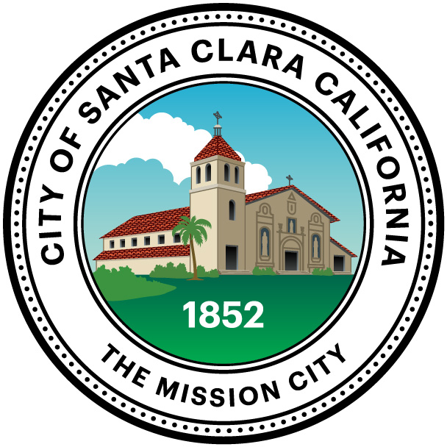
JOINT MEETING - ADA STAFF AND ADVISORY COMMITTEES
Thursday, June 11, 2015 (10:00 a.m. – 12:00 p.m.)
City of Santa Clara
City Hall Council Chambers
1500 Warburton Avenue
Santa Clara, CA

The June 11, 2015 ADA Staff and Advisory Meeting has been CANCELLED.

The next ADA Staff and Advisory Meeting is scheduled for Thursday, September 10, 2015, at 10:00 a.m. in the Council Chambers.

