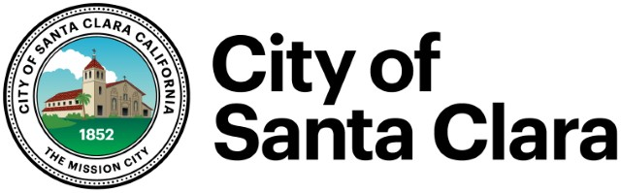

CITY SCHOOL LIAISON COMMITTEE
AGENDA
Wednesday, January 6, 2016
7:30 a.m.
City of Santa Clara – City Hall
Staff Conference Room
Santa Clara, CA 95050

- Call to Order/Introductions Chair, City of Santa Clara
- SCUSD Strategic Plan

- Local Events for Superbowl
  - Security

- Safe Routes to School Program Updates and Grant Money

- Cities of Excellence

- Development Impact Fees

- Update on the Soccer Parks

- New Developments
  - Residential/Housing Developments in the City of Santa Clara
  - International Swim Center Update
  - Central Park Plan Update

- Adjourn

The City/School Liaison Committee consists of 3 Santa Clara City Council Members; 3 Santa Clara Unified School District Board Members; and staff from both agencies.

