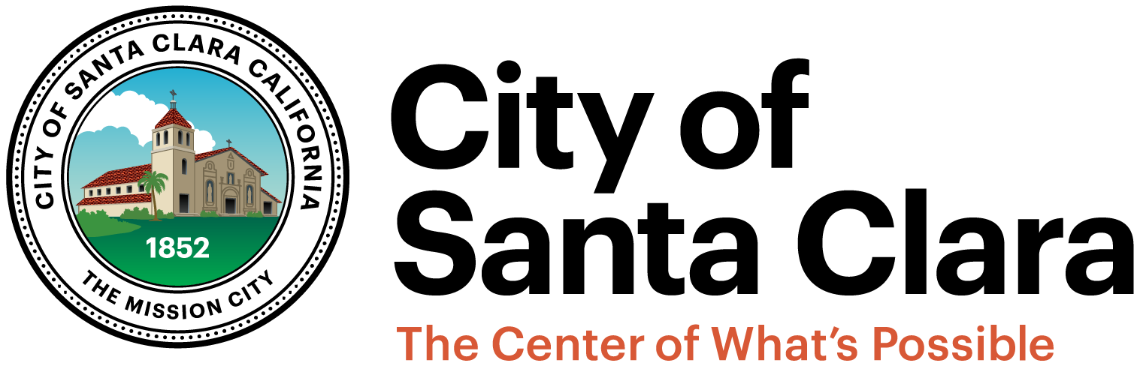
Meeting Minutes - DRAFT
Monday, November 14, 2016 – 4 p.m.
Governance Committee
SANTA CLARA CITY HALL –
CMO STAFF CONFERENCE ROOM
1500 Warburton Avenue
Santa Clara, CA
1500 Warburton Avenue
Santa Clara, CA

Committee Members | Staff
Teresa O’Neill, Vice Mayor and Chair | Rajeev Batra, Acting City Manager
Debi Davis, Council Member | Richard Nosky, City Attorney
Pat Kolstad, Council Member | Rod Diridon, Jr., City Clerk/Auditor
 | Jennifer Yamaguma, Community Relations Manager
 | Genevieve Yip, Office Specialist to the City Council
 | Attendees
 | Deborah Bress, Resident
 | Bob Brunton, Resident
 | Don Herbelin, Resident
 | Scott Lane, Resident
 | Cheri Squires, Resident
 | Kirk Vartan, Resident

- Call to Order Chair O’Neill
The Chair called the meeting to order at 4:04 p.m.

- Approval of Minutes from October 17, 2016 Committee
It was moved by Council Member Kolstad, seconded by Chair O’Neill, and
carried, that the Committee approve the minutes of the October 17, 2016 meeting. Council Member Davis abstained from the vote, as she was not present during the October 17, 2016 meeting.

- Update on Work Plan Items Chair O’Neill
& Committee
  - Review Public Comment Process
    - Increase Time Limit For Individual Speakers
The Committee discussed time limits for individual speakers during public comments. Resident Kirk Vartan made general comments regarding the time limit for individual speakers and proposed the potentiality of latitude for speakers. Council Member Kolstad commented that the two-minute time limit for public comment is helpful to keep the Council Meeting running and suggested the potential of serial presentations by groups of people that would like to present on the same topic.

    - Reorder Public Presentations on Council Agendas
The Committee discussed moving up public presentations on the Council Agenda to better accommodate residents that may have time constraints (e.g. residents that use public transportation, students). The Chair clarified that public comments have to be relevant to the jurisdiction or authority of the City; Council Member Kolstad noted that items on the agenda cannot be part of public comment. Council Member Davis made a recommendation to have the full City Council vote on whether to move up Public Presentations after Special Order of Business; to have the presentations with limited to three minutes and up to the Mayor’s discretion; and to clarify that presenters do not have to fill out a public presentation card, but that it is requested.
    - Establish total time limit for Public Presentations
The Chair discussed that the need for a total time limit has happened very rarely and that the Committee could make adjustments accordingly.

It was moved by Council Member Kolstad, seconded by Council Member Davis, and unanimously carried, that the suggestions of first two points of Item 3.a. be reflected in an updated policy. The Chair directed staff to modify Policy and Procedure 029 Time Limits for Speakers and Council Meetings for the Committee’s review before bringing it forward as agenda item for the January 9, 2017 Council Meeting; community members will be invited for their comments.

  - Review Order of Agenda Items and Discuss Implementation of Time Certain
Items
The Committee discussed that items with higher levels of interest could be potentially
heard at certain times. Resident Kirk Vartan commented that community members have left during meetings before their items could be heard and that the implementation of time certain items could help address the needs of the community. Resident Scott Lane commented that the Committee could look at other cities with time certain items as a model. Council Member Davis suggested that the Committee could survey cities of similar size to see how time certain items work for their city. The Chair directed staff to survey other neighborhood jurisdictions for time certain items and referred the discussion to the January 9, 2017 Governance Committee Meeting.

- Discussion on Citizens Advisory Commission and Preparation of a Memorandum
of Understanding
The Chair discussed that there was a lot of interest in reviewing the history of the Citizens Advisory Committee (CAC) and for the relationship between the City of the Santa Clara and the CAC to be memorialized in a Memorandum of Understanding (MOU) during the October 17, 2016 meeting. Staff reported that the proposed MOU is a rough draft. CAC Chair Cheri Squires commented that she and her board would like to review the draft MOU at their CAC meeting scheduled for November 28, 2016. The Committee further discussed the stipulations for the MOU. The Committee discussed the history of the CAC and that the MOU would clarify the relationship between the City of Santa Clara and the CAC.

- Updates from Committee Members & Staff of Other Items Listed on the Work Plan
There were no updates.

- Public Presentations
There were no public presentations.

- Adjourn
The meeting was adjourned at 5:21 p.m.

