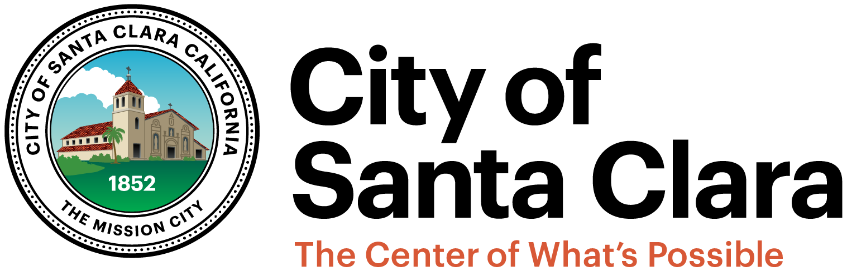
AGENDA
ETHICS COMMITTEE
City Hall – Council Chambers
1500 Warburton Avenue
Santa Clara, CA 95050
REGULAR MEETING
May 4, 2017
At 5:00 pm
Committee Members | Staff
Council Member Debi Davis | City Manager Rajeev Batra
Council Member Dominic Caserta | Interim City Attorney, Brian Doyle
Council Member Kathy Watanabe

Topic
- Call to Order
- Update on Workplan Items:
  - Charter Review Committee Update
  - Status for review of options to prohibit “dark money” in Santa Clara elections
  - Request for Proposals (RFP) Process for Ethics Consultant
- Updated Final Report by Fred Keeley, Democracy Consultant, Regarding the Ethics Component of the 2016 Santa Clara Votes Program
- Public Presentations
- Adjournment
Next meeting: June 5, 2017

