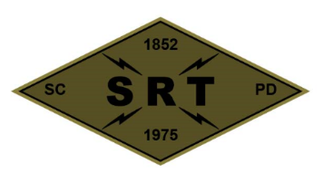

## SANTA CLARA POLICE DEPARTMENT

Special Response Team

Date: May 6th 2020

Time: 0800-1800

Lead Instructor(s): Bell, Barry, Enos, Deger,

Training location(s): Santa Clara PD

2200 Calle De Luna, Santa Clara

3055 Patrick Henry Dr, Santa Clara

Topic(s):

* Meeting with the captain (1st Floor Community Room)
* Pre-planned operation workup debrief (1st Floor Community Room)
* Mock Call-out/Pre-Planned event (SRT Garage)

Lunch

* Searching (3055 Patrick Henry Dr, Santa Clara)
  + Split into two teams
  + Approaches/Initial Entry Points/Peel
  + Hallways/intersections/room clearing/ NFDDs
    - Speed changes at each lane
      * Dynamic
      * Standing slow
      * Stealth Probe
      * HRT
  + After each team has had enough time in both lanes introduce Sims/role players scenarios
    - Dynamic Search warrant
    - Barricade
    - Hostage

Gear:

* Sim Gear/Police training signs - Revay/Williams

Source Documents **(To be reviewed before training)**:

SCPD SRT Redi-Ref

* Dynamic entry SOP- (Pg. 65-73)
* Standing slow search SOP (Pg. 74-78)
* HRT stealth probe SOP (Pg. 79-88)
* HRT Stronghold Assault (Pg. 89-96)

Covid prevention/mitigation measures:

* Temperature check on all SRT Operators prior to conducting training
* Gloves to be worn during training
* Masks to be worn during training
* Dedicated sanitizing sprays/wipes
* Social distancing practiced whenever feasible