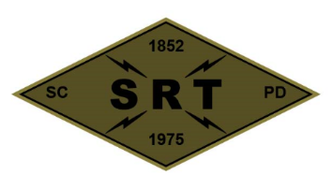

## SANTA CLARA POLICE DEPARTMENT

Special Response Team

*BREACHER TRAINING*

Date: June 29th, 2020

Time: 1200-2000

Lead Instructor(s): Sgt. Erickson

Training location(s): Santa Clara PD

2200 Calle De Luna, Santa Clara

Topics to be covered:

* Wall entry breaches
  + Experiment with different tamping materials
  + Slider charge(s)
* Gunport box charges
  + On studs
* Fire Hose expeditionary plan
* Slider charge(s)
* Manual Tools

Source Document(s):

* SCPD SRT Redi-Ref
* Breacher’s Brief (Pg. 23)
* Dynamic Entry SOP (Pg. 65)
* Los Angeles County Sheriff’s Department – SEB Explosive Breaching Course
* SRT Tactical Breaching Manual
* TEES Mechanical, Thermal, and Explosive Breaching Manual

COVID prevention/mitigation measures:

* Masks to be worn during training as needed
* Dedicated sanitizing sprays/wipes
* Social distancing practiced whenever feasible