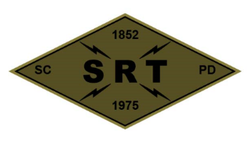

## SANTA CLARA POLICE DEPARTMENT

Special Response Team

Date: August 26, 2020

Time: 0800-1900

Lead Instructor(s): Gutierrez/Pianto/Van Diemen/Barry

Training location(s): SCPD Range (1950 Walsh Av, Santa Clara)

| 8/26/20 | Activity | Personnel | Location |
| --- | --- | --- | --- |
| 0800-0930 | Team Workout | SRT | Santa Clara PD |
| 0930-1130 | Dry Runs – Approach/Hallways | SRT | SCPD Range |
| 1130-1300 | Team Live Fire/White Board Ex | SRT | SCPD Range |
| 1300-1400 | Lunch | SRT | N/A |
| 1400-1700 | Team Live Fire/White Board Ex | SRT | SCPD Range |
| 1700-1800 | Weapons Maintenance | SRT | SCPD Range |
| 1800-1900 | Team Building | SRT | TBD |

Gear:

Call out gear – Individual Operator’s responsibility

Source Document(s):

California POST Operational Guidelines and Standardized Training Recommendations

COVID prevention/mitigation measures:

* Deny participation of those showing symptoms (includes temperature check)
* Utilize gloves and facemasks
* Keep sanitizing sprays/wipes at all training locations
* Exercise social distancing whenever feasible