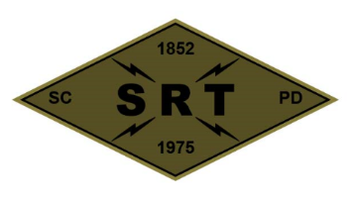

## SANTA CLARA POLICE DEPARTMENT

Special Response Team

Date: March 23-25, 2021

Time: 0800 – 1900

Training location(s): Embassy Suites (2885 Lakeside Drive, Santa Clara CA

* 3 Day Sid Heal class surrounding Tactical Decision Making

Gear:

Civilian Clothes

COVID prevention/mitigation measures:

* Deny participation of those showing symptoms (includes temperature check)
* Sanitizing sprays/wipes will be kept at all training locations
* Wear face masks as appropriate
* Exercise social distancing whenever feasible

**Attendees:** Mitch Barry, AJ Pianto, Randy Van Diemen, DJ Bell, Jordan Fachko, Justin Mead, Jeff Revay, Steven Stek, Kevin McColloch, Bryan Williams, Shaun MacKay, Dustin Silva, Jeremy Schmidt, Rob Gutierrez, Scott Tyler, Chris Gilmer, Kevin Mead, Scott Mead, Nick Richards, Luke Erickson