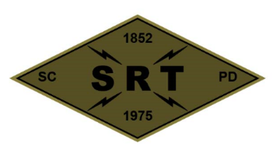

## SANTA CLARA POLICE DEPARTMENT

Special Response Team

Date: May 27, 2021

Time: 0800 – 1900

Training location(s): SRT Garage / SCFD Station 2 / SCPD Range / 1601 Civic Center

* **Team Meeting at SCPD**
  + 5/24/21 Callout Debrief
  + NFD PowerPoint
  + Team Business
* **SCFD Station 2**
  + NFD Deployments
* **SCPD Range**
  + Dynamic Entry Fundamentals
* **Lunch (1200 – 1300)**
* **1601 Civic Center** 
  + Scenarios

Gear:

Full Callout gear

**Attendees:** Mitch Barry, AJ Pianto, Randy Van Diemen, DJ Bell, Jordan Fachko, Justin Mead, Jeff Revay, Steven Stek, Kevin McColloch, Bryan Williams, Daniel Khairy, Robert Lyman, Dustin Silva, Jeremy Schmidt, Rob Gutierrez, Scott Tyler, Chris Gilmer, Kevin Mead, Scott Mead, Nick Richards, Luke Erickson, Logan Clevenger, Kylee Palma