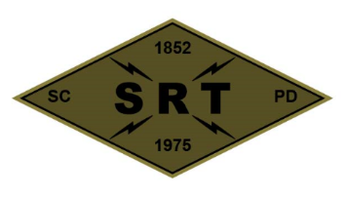

## SANTA CLARA POLICE DEPARTMENT

Special Response Team

*BREACHER TRAINING*

Date: 8/16/21

Time: 1100-2100

Lead Instructor(s): Jeremy Schmidt

Training location(s): Santa Clara PD

Topics to be covered:

* Annual Explosives Inventory
* Manual Tools Inventory
* Shotgun Breaching Overview
* Stadium Breach Plan

Source Document(s):

* SCPD SRT Redi-Ref
* Breacher’s Brief (Pg. 23)
* Dynamic Entry SOP (Pg. 65)
* Los Angeles County Sheriff’s Department – SEB Explosive Breaching Course
* SRT Tactical Breaching Manual
* TEES Mechanical, Thermal, and Explosive Breaching Manual

COVID prevention/mitigation measures:

* Masks to be worn during training as needed
* Dedicated sanitizing sprays/wipes
* Social distancing practiced whenever feasible