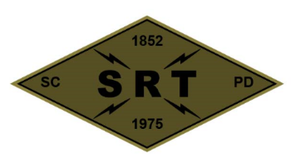

SANTA CLARA POLICE DEPARTMENT

Special Response Team

Date: September 30, 2021

Time: 0800 – 1900

Training location(s): Santa Clara County SO Range (Pad 1) – 9600 Malech Road, San Jose CA

* 0800 – Meet at SRT Garage and grab necessary equipment.
* 0830 – Leave PD to drive to the SO Range
* 0915 – Safety Check with complete SIMS
* 0930 – ARV Operations/Vehicle Assaults
* 1200 – Lunch
* 1300 – Safety Check with live fire scenarios
* 1600 – Range/Equipment Cleanup
* 1700 – Drive Back to SCPD
* 1800 – OD

Gear:

SRT BDUs, full callout gear, all SIMS gear

**Attendees:** Mitch Barry, AJ Pianto, Randy Van Diemen, DJ Bell, Jordan Fachko, Justin Mead, Jeff Revay, Steven Stek, Kevin McColloch, Bryan Williams, Daniel Khairy, Robert Lyman, Dustin Silva, Jeremy Schmidt, Rob Gutierrez, Scott Tyler, Scott Mead, Nick Richards