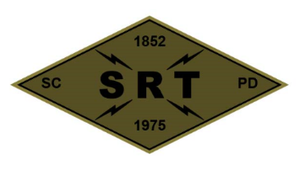

SANTA CLARA POLICE DEPARTMENT

Special Response Team

Date: November 18, 2021

Time: 0800 – 1900

Training location(s): SCPD, SCFD Station 2, 1601 Civic Center in Santa Clara

* 0800 – Meet at outside gym at PD for Team WO
* 0900 – Meet at Fire Station 2 for CS Gas Exposure
* 1015 – Break for Lunch
* 1115 – Meet at 1601 Civic Center
* 1130 – Searching and Hostage Rescue Tactics
* 1700 – Cleanup at Training site
* 1800 – SCPD for new body armor gear issuance
* 1900 – OD

Gear:

SRT BDUs, full callout gear, all SIMS gear

**Attendees:** Mitch Barry, AJ Pianto, Randy Van Diemen, DJ Bell, Jordan Fachko, Justin Mead, Jeff Revay, Steven Stek, Kevin McColloch, Bryan Williams, Daniel Khairy, Robert Lyman, Dustin Silva, Jeremy Schmidt, Rob Gutierrez, Scott Tyler, Scott Mead, Logan Clevenger