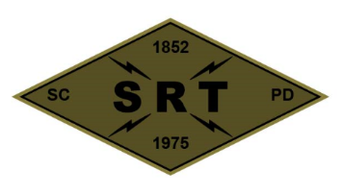

## SANTA CLARA POLICE DEPARTMENT

Special Response Team

*BREACHER TRAINING*

Date: 4/27/22

Time: 0700-1700

Lead Instructor(s): Jeremy Schmidt

Training location(s): SCPD

Topics to be covered:

* Set up team training for April
* Lyman to brief team on TEES training
* Saw demonstration with SCFD
* Scout training sites
* Tool inventory and discussion
* Prepare materials for team training

Source Document(s):

* SCPD SRT Redi-Ref
* Breacher’s Brief (Pg. 23)
* Dynamic Entry SOP (Pg. 65)
* Los Angeles County Sheriff’s Department – SEB Explosive Breaching Course
* SRT Tactical Breaching Manual
* TEES Mechanical, Thermal, and Explosive Breaching Manual

COVID prevention/mitigation measures:

* Masks to be worn during training as needed
* Dedicated sanitizing sprays/wipes
* Social distancing practiced whenever feasible