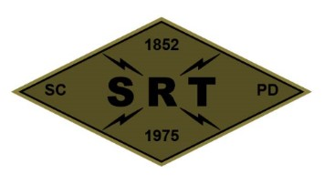

**Santa Clara Police Department SRT**

**Training Plan**

**Date:** 9/29/22

**Time:** 0800 to 1900 hours

**Location:** SCPD Range – 1990 Walsh Avenue Santa Clara

**Primary Instructors:**

Ofc. Gutierrez, Ofc. Stek, Ofc. Pianto, & Ofc. Van Diemen

**Training Topic(s):**

**Physical Training –** PT will be incorporated throughout

**Training Topic –** SRT Pistol & Rifle Qualification

Positional shooting (Barricades/Windows)

Malfunction & Transition Drills

Room entries with threat assessment

Team movement

Search tools/equipment

NFDD (simulated) deployments

**Training Overview –** The team will be split in half. Half will complete the SRT Pistol and Rifle Qualification. Once the qual has been completed, operators will work on live fire movement drills.

The other half of the team will work on fundamental movements in the sim house and the use of our equipment. The teams will switch after each training evolution is complete.

After lunch, the team will receive training on the new shields. Operators will use the shields during a variety of operations including searching, HRT in a structure, and HRT in a vehicle.

Training will conclude with cleaning and equipment maintenance.

**Equipment/Assignments:**

**Individual:** Full SRT uniform, all callout equipment, specialty equipment, and sim equipment. **Please bring lunch**.

**Team:** Somerville – SRT Van and training bangs

Bailey & Schatz – ARV, Water, Trauma kit and AED

McColloch – Evac vehicle

Stek – Quals & Shields

Gutierrez – Quals

Khairy – Bureau car

**Role Player(s):** Clevenger & Palma if available

**Schedule:**

0800 – Dressed and vehicles loaded at SRT Garage for team meeting

0830 – Split team for training evolutions

1030 - Switch

1200 – Lunch (Working lunch)

1300 – Shield work

1630 – Site Cleanup

1700 – SRT gear/equipment/facility maintenance and inspection

1800 – Return to SCPD – Clean garage/lockers

1900 – Off Duty

**Safety Plan (attached)**