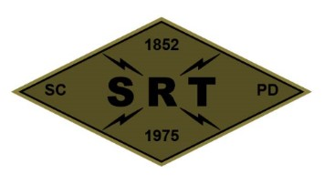

**Santa Clara Police Department SRT**

**Training Plan**

**Date:** 6/29/23

**Time:** 1000 to 2100 hours

**Location:** Levi’s Stadium and 5200 Patrick Henry Drive

**Primary Instructors:** Sergeants and TLs

**Training Topic(s):**

**Training Topic –** Levi’s Stadium overview

Open Field Movement/SRT’s response to bomb/explosives

at the stadium

Vehicle blocks with SET

**Training Overview –** Operators will conduct training related to the above listed training topics. The training will be designed to introduce new SRT members to the training topics and give a refresher to others with regards to Levi’s Stadium operations. The training will progress into scenarios focused on stadium related incidents. There will be limited down time between scenarios. Scenarios will be adjusted based on the performance/needs of the team or individual operators. Training will conclude with cleaning and equipment maintenance.

**Equipment/Assignments:**

**Individual:** Full SRT uniform, all callout equipment, specialty equipment, and sim equipment. **Please bring your meal**.

**Team:**

Schatz/Duran – Van/Waters

Stek/Somerville – Sim equipment (2 role players and ammo)

McColloch – Evac vehicle

Yee – Trauma bag/AED

**Role Player(s):** TBD

**Schedule:**

1000 – Meet in the SRT garage

1040 – Depart for the stadium to post 3

1100 – Stadium briefing room (Mead and McColloch)

1300 – Exterior tour/hotel visits (Schmidt)

1500 – 5200 Patrick Henry / Scenarios (Mead and Barry)

1700 – Code 7

1800 – Vehicle Blocks w/SET tactics (SET Personnel)

2030 – Clean garage & gear maintenance

2100 – Off Duty

**Safety Plan (attached)**