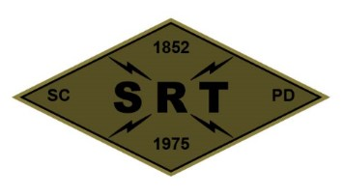

**Santa Clara Police Department SRT**

**Training Plan**

**Date:** 10/26/23

**Time:** 1000 to 2100 hours

**Location:** 6289 Madigan RD, Dublin CA., 94568

**Primary Instructors:** Breaching Cadre, Team Sergeants and TLs

**Training Topic(s):**

**Physical Training –** PT will be conducted prior to training.

**Training Topic –** Hostage Rescue Tactics

NFDD Deployments

**Training Overview –** A team meeting at the SRT garage will begin at 1000. After the team meeting, the team will travel to the Dublin training site (an approximate 45-minute drive). The training will cover hostage rescues tactics and NFDD deployments. At the conclusion of training, the training site will be cleaned and inspected. The team will return to the SRT garage for additional gear and equipment maintenance and inspection.

**Equipment/Assignments:**

**Individual:** Full SRT uniform, all callout equipment, specialty equipment, and sim equipment. **Bring your meal (x2)**.

**Team:**

Schatz/Duran – Van/Waters

Eagen/Somerville – Sim equipment (2 role players and ammo)

Yee – Trauma bag/AED

**Role Player(s):** TBD

**Schedule:**

1000 – Team Meeting at SRT Garage

1015 – Leave for training site

1130 – Safety checks complete

1130 – Scenarios

1400 – Lunch

1500 – Scenarios

1830 – Site Cleanup/return to PD

2030 – Clean garage & gear maintenance

2100 – Off Duty

**Safety Plan (attached)**