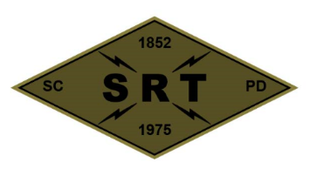

## SANTA CLARA POLICE DEPARTMENT

Special Response Team

*BREACHER TRAINING*

Date: 7/1/24

Time: 0800-1500

Lead Instructor(s): Walsh, Anderson, Schmidt

Training location(s): SJPD MERGE

Topics to be covered:

* Review of energetics terms and nomenclature
* Energetic calculations
* Incident debriefs

Source Document(s):

* SCPD SRT Redi-Ref
* Breacher’s Brief (Pg. 23)
* Dynamic Entry SOP (Pg. 65)
* Los Angeles County Sheriff’s Department – SEB Explosive Breaching Course
* SRT Tactical Breaching Manual
* TEES Mechanical, Thermal, and Explosive Breaching Manual

COVID prevention/mitigation measures:

* Masks to be worn during training as needed
* Dedicated sanitizing sprays/wipes
* Social distancing practiced whenever feasible