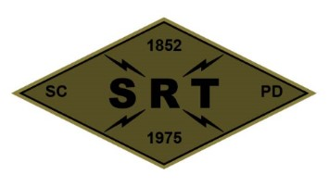

**Santa Clara Police Department SRT**

**Training Plan**

**Date:** 07-08-2024

**Time:** 1000 - 2100 hours

**Location:** SJPD Stables – 2525 Kenoga Dr., San Jose, CA

**Primary Instructors:** Pianto, McColloch, C. Rodriguez

**Training Topic(s):**

**Physical Training –** PT Will be conducted prior to training.

**Training Topic –** K-9 Integration with SRT

**Training Overview –** A team meeting at the SRT garage will begin at 1000. After the team meeting, the team will travel to SJPD Stables and begin safety checks by 11:00 am. The training will cover K-9 integration with SRT tactics. At the conclusion of training, the training site will be cleaned and inspected. The team will return to the SRT garage for additional gear and equipment maintenance and inspection.

**Equipment/Assignments:**

**Individual:** Full SRT uniform and all callout equipment.

**Team:**

Duran– SRT Van, water, training signs, sim gear & ammo

Eagen – ARV, Trauma kit and AED, Site Cleaning Equipment

Rodriguez – Marked evac vehicle

Bell – White Van

**Role Player(s):** TBD

**Schedule:**

1000 – SRT Garage

1100 – Safety checks begin

1115 – Scenarios

1630 – Lunch

1730 – Scenarios

1930 – Site Cleanup/return to PD

2030 – Clean garage & gear maintenance

2100 – Off Duty

**Safety Plan (Attached)**