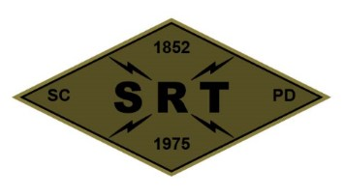

**Santa Clara Police Department SRT**

**Training Plan**

**Date:** 08-05-2024

**Time:** 1000 to 2100 hours

**Location:** Metcalf Shooting Range – 9580 Metcalf Road, San Jose

**Primary Instructors:** Steve Stek and Steve Somerville

**Training Topic(s):**

**Physical Training –** PT will be conducted prior to training.

**Training Topic –** Team Range Day

Shooting at Distance

Bounding and Overwatch

Shooting Around Vehicles & Bearcat

**Training Overview –** A team meeting at the SRT garage will begin at 1000. After the team meeting, the team will travel to Metcalf Shooting Range. Live fire courses will incorporate use of the outdoor 200-yard range. At the conclusion of training, the training site will be cleaned of brass and inspected. The team will return to the SCPD Range / SRT Garage for additional gear and equipment maintenance and inspection.

**Equipment/Assignments:**

**Individual:** Full SRT uniform and all callout equipment.

**Team:**

Schatz – Van / Waters

Eagen – Medic Evac Vehicle (Candy Van) with Med Bag & AED

Duran – Bearcat

Stek/Somerville – Range Equipment, Ammo, Supplies

**Schedule:**

1000 – SRT Garage

1100 – Safety Briefing at Metcalf Range and Range Setup

1130 – Live Fire Courses

1330 – Lunch

1430 – Live Fire Courses

1900 – Site Cleanup / Return Supplies to Range

2000 – Clean Weapons & Gear Maintenance at SCPD Range

2100 – Off Duty

**Safety Plan (Attached)**